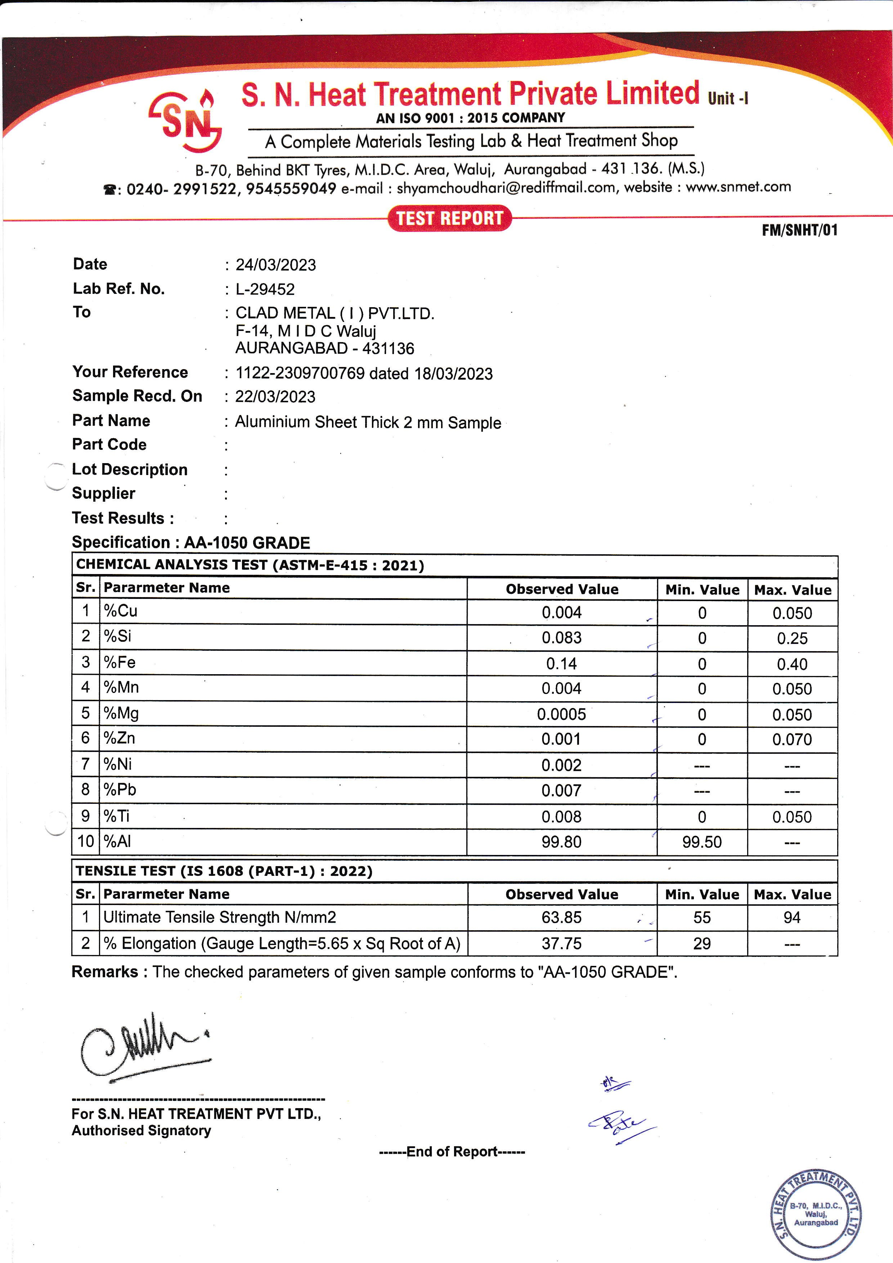

|  |  |  |  |  |
| --- | --- | --- | --- | --- |
| **Date :** 24/05/2024 | | | | |
| **Lab Ref.No :** L-05672 | | | | |
| **To :** CLAD METAL ( I ) PVT .LTD | | | | |
| F-14 M I D C Waluj | | | | |
| AURANGABAD - 431136 | | | | |
| **Your Reference :** 00324 dated 20/05/2024 | | | | |
| **Sample Recd.On :** 20/05/2024 | | | | |
| **Part Name :** HY Foil Size 0.105 Sample | | | | |
| **Part Code :** | | | | |
| **Lot Description :** | | | | |
| **Supplier :** | | | | |
| **Test Results :** | | | | |
| **Specification : CHEMICAL ANALYSIS (ALUMINIUM ALLOYS)** | |  |  |  |
| **CHEMICAL ANALYSIS TEST (ASTM-E-1251 : 2017)** | | | | |
| **Sr.** | **Parameter Name** | **Observed Value** | | |
| 1 | % Si | 0.53 | | |
| 2 | %Cu | 0.043 | | |
| 3 | %Mn | 0.008 | | |
| 4 | %Mg | 0.004 | | |
| 5 | %Fe | 0.71 | | |
| 6 | %Pb | 0.006 | | |
| 7 | %Zn | 0.001 | | |
| 8 | %Ni | 0.001 | | |
| 9 | %Sn | 0.001 | | |
| 10 | %Cr | 0.004 | | |
| 11 | %Al | 98.62 | | |
| **Remarks:** Our finding as per above. | | | |  |

13/02/2023

L-29467

CLAD METAL ( I ) PVT.LTD.

F-14, M I D C Waluj

AURANGABA – 431136

1122-2309700637 dated 07/02/2023

07/02/2023

Aluminum sheet thick 2 mm Sample